**A title for your project proposal**

E-sports Data Analysis - League of Legends Professional Tournaments

**A detailed but concise description of your for your proposal that includes the following:**

1. **What is the main question you are answering?**

* I would like to research in this season, which group of champions are most competitive?
* Who are those champion’s counter-picks?
* What is the performance when they in the same game?
* What is the win rate change when a specific champion fights his/her counter-pick rival?

1. **What data sources do you plan to use?**

Data Source comes from this website： <https://oracleselixir.com/stats/champions/explorer>

Sample picture for the data source, I have already downloaded to my GitHub repo.

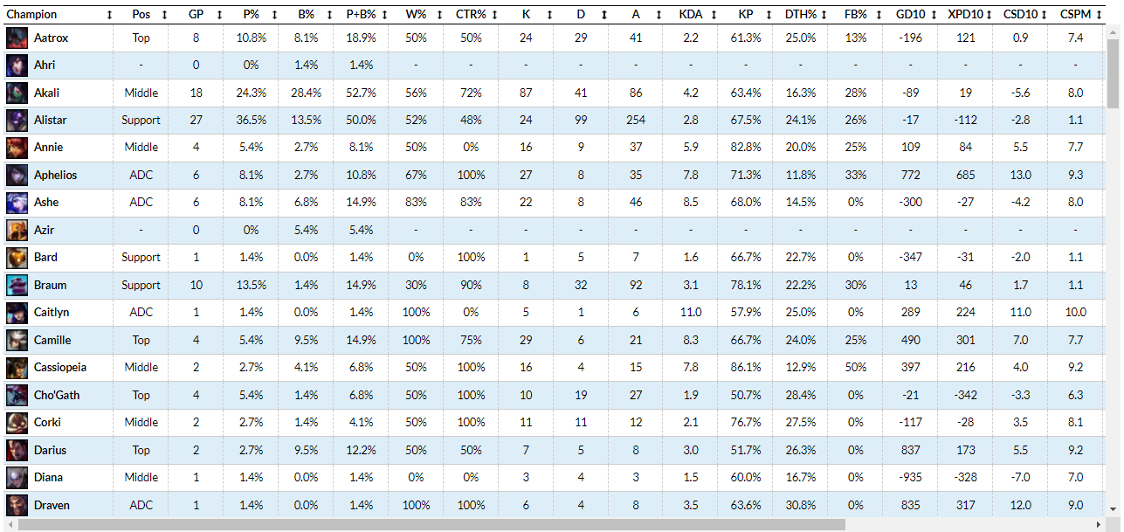

1. **What methods will you apply to these datasets?**

Python OOP, pandas, scikit learn, matplotlib.

1. **What will you produce? For instance, a project proposal could include the following: a report, a PowerPoint presentation, a code notebook (e.g., Google Collab, R Markdown, etc.), a GitHub repository with code.**

I will create a python class/function to give out a recommendation champion when I input a champion’s name.

GitHub repository: <https://github.com/yming2-bu/BA890-Research-Project>

1. **What are your expected findings?**

I will find the best gaming strategy for picking the right champions.

I will compare the gaming strategy change trend between 2019 to 2021 seasons.